**Manage Catalog**

The catalog has several elements like the category, product attributes, product modules, and manufacturer modules. This section helps you to easily and smoothly manage the product catalog of your marketplace. It has all the functionalities embedded that are necessary!

**Attention!** There might not be complete access to all the modules of the catalog section due to certain marketplace rules.

Elements involved with this module are the ones mentioned here.

* Categories
* Product Attributes
* Products
* Manufacturers

**Categories**

This entire module is categorized into 3 subdivisions that are group, sub-group, and category. The *Category group* is the initial division for grouping the listed product and organize it. There can be multiple *sub-groups* in a category group, and there can be multiple *categories* under a sub-group.

CATALOG >> CATEGORIES

**Attention!** If you cannot see the option for a category in your navigation menu, then there might be a case that the vendors are not allowed access to this module by the admin of the marketplace. For having access, you can make a request to the admin for complete or partial access to this module. You can request for the desired category to be available for using it for the product listings.

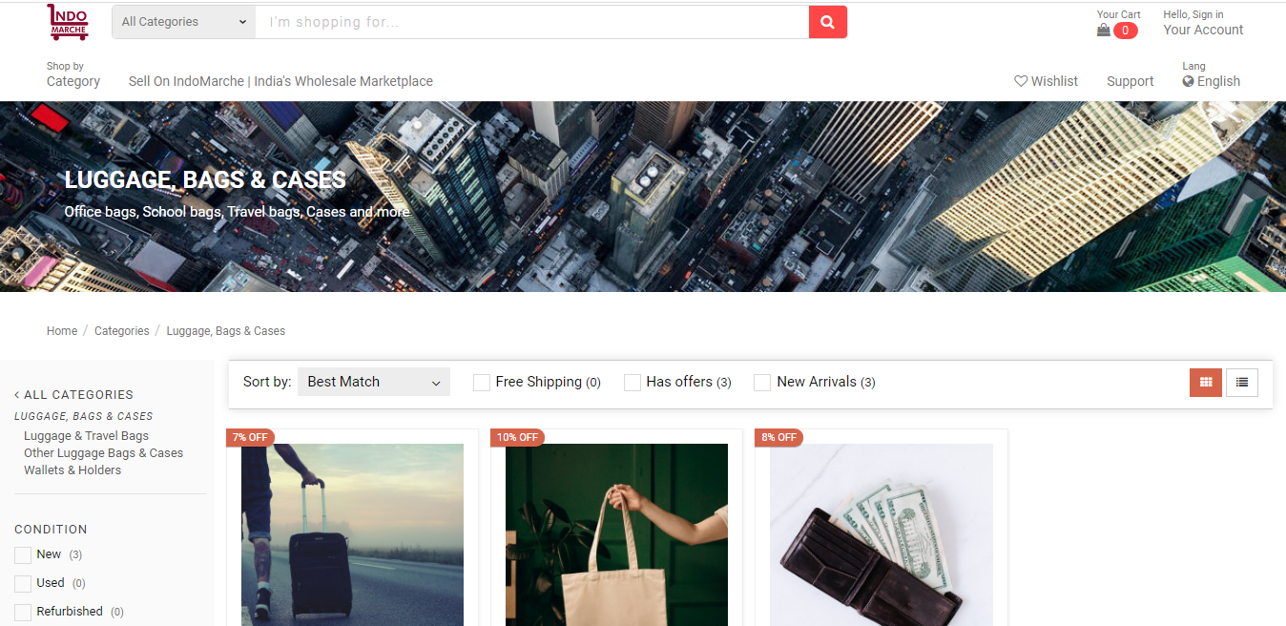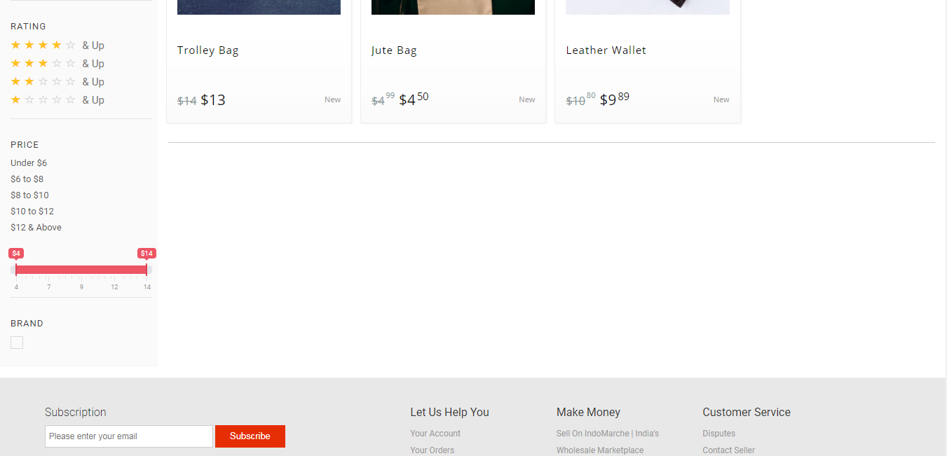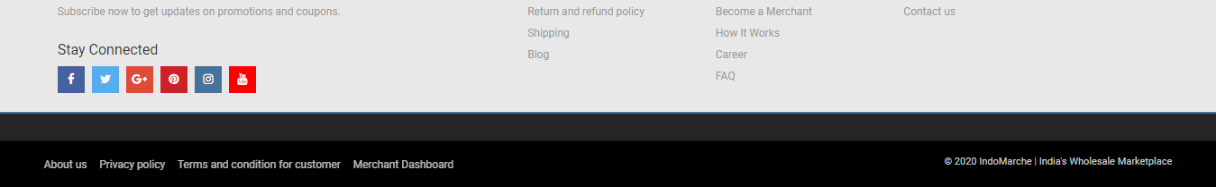

*Category Groups*

The category listing can be done for your product that is visible on the marketplace’s landing page, where the customers/ visitors navigate to through the *Shop by Category* dropdown. A catchy icon is set at the left side of the dropdown list. Inside that, several icons are embedded that allows searching for the products in the respective categories.

CATALOG >> CATEGORIES >> GROUPS

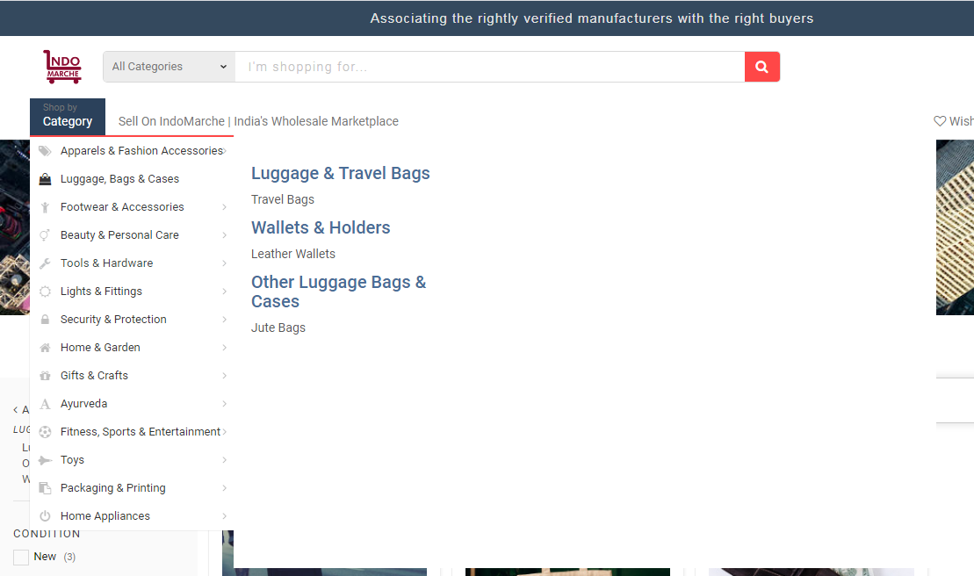

*Category Sub-group*

It can be considered as the parent category of the end categories that are labeled. It can hold many end categories that are helpful to organize the catalog efficiently.

Having a glance over this section will ease the managing of the sub-groups!

CATALOG >> CATEGORIES >> SUB-GROUPS

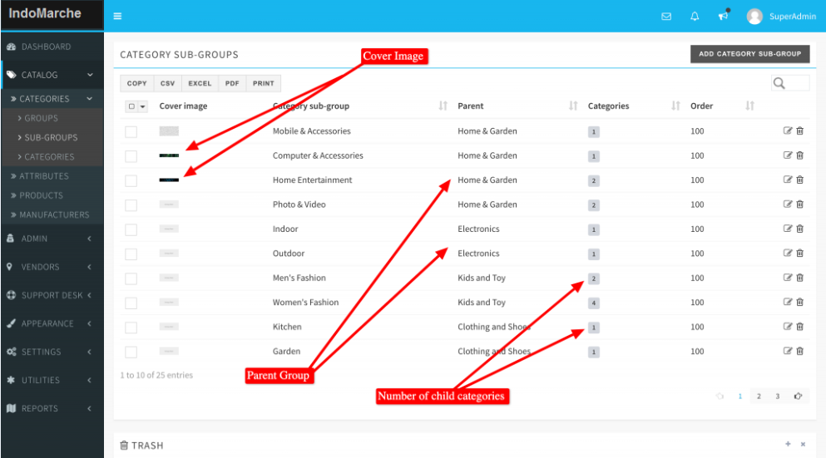

*Category*

It is the final and last label. All the products come directly under this section. An image is set to get the right information about the products included in the category.

CATALOG >> CATEGORIES >> CATEGORIES

**Warning!** If the admin removes or deletes any parent Group of Sub-group, then all the child entities associated with that get removed too.

**Product Attributes**

Three types of product attributes are available with IndoMarche.

*Color/Pattern:* This is a unique attribute type. In this, the image of the color or the pattern can be selected as an attribute value and it will also be shown as an option on the product page. These images are displayed on the description in place of the attribute name. However, these images are meant to be the tiny ones to fit in properly.

*Radio:* This is the basic radio attribute type. Here, a dropdown box is shown as a list of options on the product page.

*Select:* This attribute type is similar to the radio type and in this too a dropdown box is shown with the options on the product description page.

CATALOG >> ATTRIBUTE

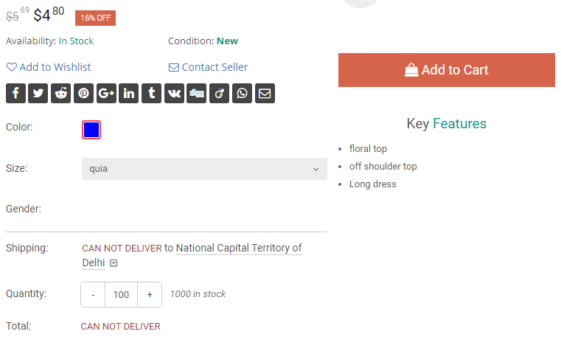

**Products**

It is a prime module of the catalog section with an array of options available. This is a generic description of the product along with some steps and set of rules to ease the addition of the product listings for the merchants. A product can have unlimited listings from several merchants dealing with it. On deactivating the product from here, all the listings of that product go offline from the storefront, and thus the merchant has no right to deactivate it.

Merchants are allowed to add/edit the products to the catalog if they wish to!

**Attention!** A product added by a merchant can only be deleted by him/her if there are no more listings available for that product.

CATALOG >> PRODUCTS

*Catalog Rules:*

You can decide and set if the product can be added with multiple variants and whether you want to ship the physical item or not. Price boundaries might also be set for an item to allow you to set a price within the limits for listing that in the inventory. This is mandatory to keep the marketplace safe from frauds and unwanted listings.

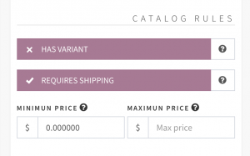

*Product Images:*

Multiple images and featured images too might be there from the admin or the one creating a product. The images will only be visible if there is no image available in the other merchant’s listing. This is completely based on the choice to add a default image with the product or not. A featured image is however preferred to ease the product searching for the merchants while creating a listing.

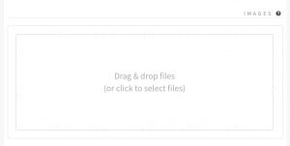

**Manufacturers**

Manufacturers or brands can be managed with the help of this module. The visitor/ customers of IndoMarche will be able to visit the Brand page to check all the listings from the same brands coming from the different merchants. This is necessary to add extra value to the portal.

CATALOG >> MANUFACTURERS

